

Natural herbicides
The Natural Herbicides Project of Engineers for A Sustainable World at Georgia Tech has conducted award-winning research on creating natural herbicide formulations that are safe, organic, and effective.

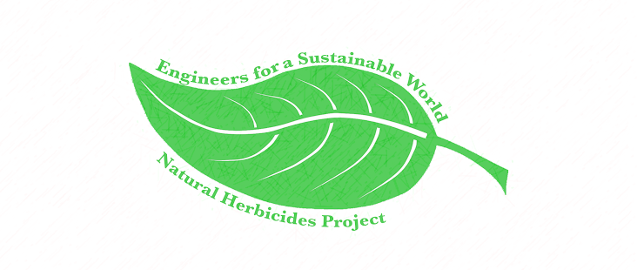
Contents
Introduction 1
How It All Works 2
Preparation of the Herbicide 3
Applying the Herbicides 4
Post Application 5
Contact Information 6

Introduction
Between 1996 and 2011, herbicide use in the United States has increased by 239 million kilograms. This massive addition of chemicals into our natural environment inevitably comes with its own set of environmental risks, including environmental runoff polluting water in nearby rivers and streams and reducing the resiliency of the lands on which they are used. Two popular herbicides used in the United States are Roundup and 2,4-D. Millions of pounds of these herbicides are applied every year, but each has been scientifically proven to have significant health risks. The movement towards natural herbicides has come out of a need to lessen society’s dependence upon the excess amounts of chemicals involved in food production while diversifying the food source. Many urban areas import crops from across the country and do not produce many fruits and vegetables nearby, creating an environment known as a food desert. Food deserts are generally defined as low-income areas where a substantial number or share of residents has low access to fresh produce and healthy groceries for affordable prices. The relationship between access to stores and dietary intake finds that better access to a supermarket or large grocery store is associated with healthier food intakes.
We hope to see that natural herbicides will improve, sustain, and overall help our community. By providing a cost-effective solution to controlling weeds organically, they can decrease our dependence upon chemical herbicides. Natural herbicides can also increase the success of local growers by enabling them to achieve weed control more effectively in sustainable food production systems. These growers often struggle to handle the high costs of the limited previously available natural weed control methods but would benefit from qualifying as organic producers and using herbicides that do not damage the resiliency of their gardens. Because of this, natural herbicides can help alleviate the problems of food deserts by enabling small local growers to have a healthy garden at a lower cost.

Natural Herbicides Project
Engineers for a Sustainable World – GT Chapter


How It All Works
Our natural herbicide solution of acetic acid and d-limonene works by penetrating the cuticle of the plant upon contact. The ingredient d-limonene can dissolve cuticular waxes, and the low pH of acetic acid can stimulate the opening of stomatal strips. This allows for the entry of the herbicide into the plant. It can then disrupt the membrane of the plant cells it contacts, resulting in cellular leakage. This makes plants dry out, turn brown, and experience death. While the herbicide damages the cells it touches, it does not translocate throughout the plant. Because of this, if you accidently let it touch one part of a desired plant, the entire plant will not be affected, but you must ensure that you apply the herbicide thoroughly to any plants you do want to kill.
A benefit that our solution has over commercial chemical herbicides is the safety of our two active ingredients, acetic acid and d-limonene. Acetic acid is a component of the same vinegar used in salad dressings or household cleaners, and d-Limonene is generally recognized as safe by the FDA for human consumption as a flavoring agent. This natural solution serves as a replacement to glyphosate, a probable carcinogen. It also has no residual effects, causes no long-term change to the soil’s pH, and does not harm pollinators like traditional herbicides.
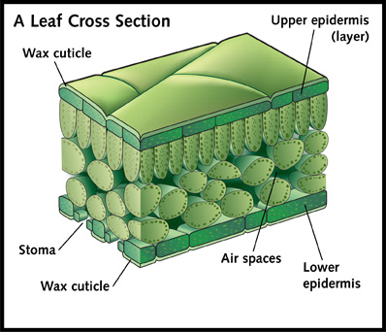

Preparation of the Herbicide
To make one gallon of our solution, the following ingredients/equipment will be needed. Personal applicators (such as reused cleaner spray bottles) can be used in place of the one recommended, but changes to the solution mixture should be made with caution as they may lead to a reduction in efficacy. Most spray bottles allow for one to evenly spray the herbicide over an entire plant.

Items:
64 oz of 20% Acetic Acid Vinegar
12.8 oz of d-Limonene
51.2 oz of Water
Chapin 20000 1 Gallon Lawn and Garden Sprayer
To create the solution, first mix the liquid components in a closed container (the applicator can be used). Mix for one minute and let settle.

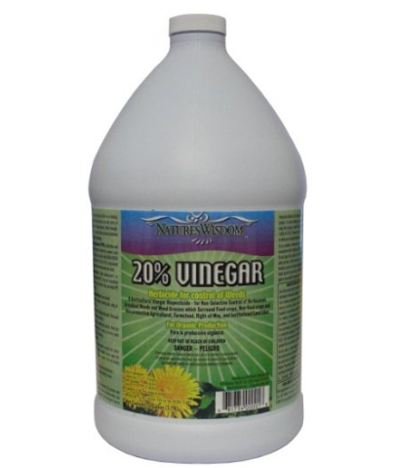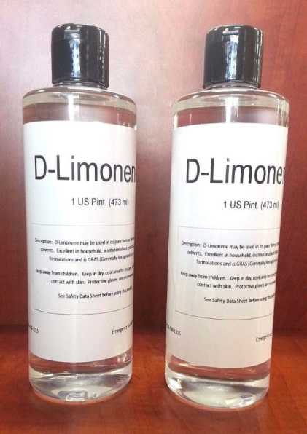

Applying the Herbicides
1. Perform spot treatment (the application of the herbicide to the plants you want to kill) to obtain results as shown on left. Make sure to apply the herbicides directly to ONLY the plants you want to kill and avoid letting them touch the plants you don’t want to kill.
2. Apply during the hottest period of a sunny day with little to no wind and no expectant rainfall within 24 hours if possible.
3. Apply when the weeds are in their early stages of growth with only one-to-two leaves if possible.
4. Re-apply when weeds begin to regrow (around every four weeks).

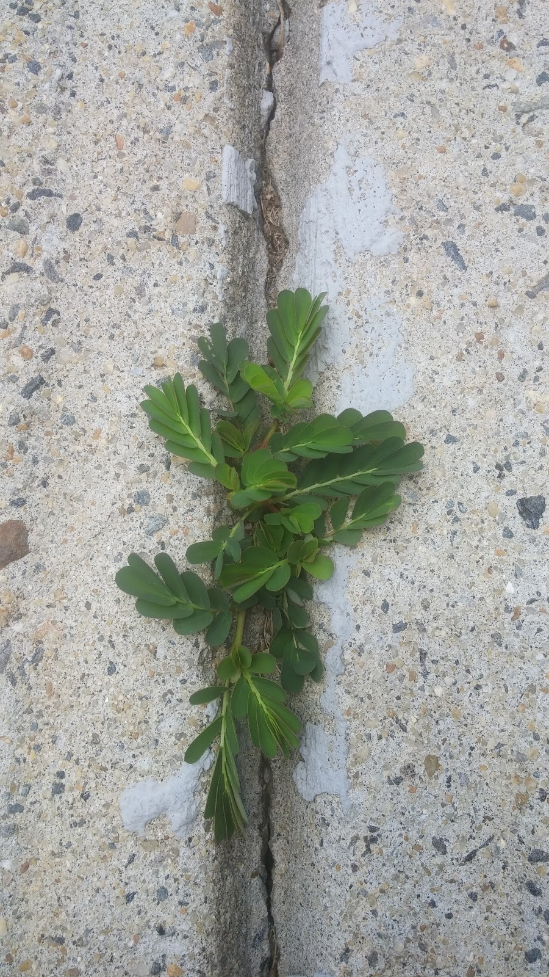Before: After:

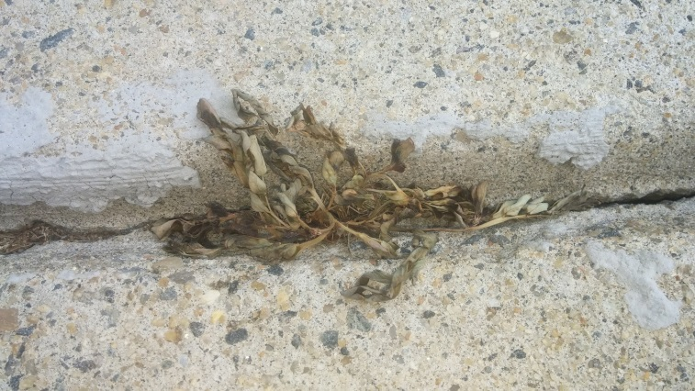

Post Application
Amazing! You have made and applied your very own natural herbicide solution! Our team could come help out with your garden at approximately monthly intervals, bringing and applying our natural herbicides as needed. Another option is that our team could give you a year’s supply of herbicides if you could complete an assessment of how the herbicides work in your garden and share pictures with us.
For any questions, comments, and aid, our team’s contact information can be found in the next section.
Also, if you would be so kind as to share your experience with the solution, please fill out our survey at https://goo.gl/forms/m68YisxSa5V5FykD2. We strive to improve our solution and our interactions with the community.

Contact Information
The Natural Herbicides project was officially started under Engineers for a Sustainable World in 2014 after initial research concerning the subject by Grace Brosofsky. Initially, our team started this project to develop and test a natural herbicide solution in comparison to commercial chemical solutions. After success with our test trials in our Georgia Tech greenhouse and on campus lawns, we decided to expand our goals to make a difference in our local community. With this solution, we hope to empower gardeners to effectively grow produce by lessening their dependence on chemical herbicides. Through holding educational sessions, we are actively providing gardeners with applicable information on how to control weeds naturally and educating growers of the environmental benefits of using natural herbicides. Ultimately, we strive to create a network of individuals working to promote sustainable living practices.
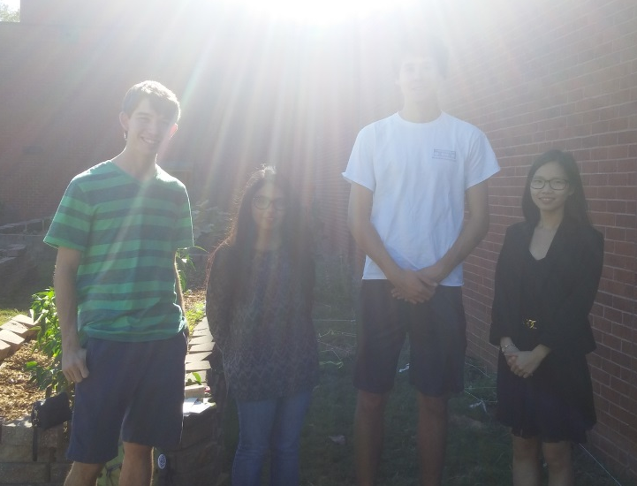

Natural Herbicides
Natural Herbicides
Engineers for a Sustainable World – GT Chapter
Tel 678-464-7548
naturalherbicidesproject.esw@gmail.com or gracebrosofsky@gatech.edu

